**Media StarX**

**Introduction:**

In an increasingly connected world, social media platforms serve as vital conduits for communication, collaboration, and community engagement. With the advent of Media StarX, a cutting-edge social networking platform, users now have access to a dynamic ecosystem designed to foster meaningful interactions, facilitate content sharing, and empower individuals to express themselves freely.

Media StarX represents the convergence of innovative technology and user-centric design principles, providing a seamless and intuitive user experience. From robust authentication mechanisms to advanced post management features, Media StarX sets a new standard for social media platforms, catering to the diverse needs and preferences of modern-day digital citizens.

At its core, Media StarX is more than just a networking tool—it's a digital playground where ideas flourish, connections thrive, and creativity knows no bounds. Whether users are seeking inspiration, forging new friendships, or amplifying their voices on global issues, Media StarX serves as the ultimate catalyst for social engagement and digital empowerment.

This project aims to develop a social media web application where users can browse, interact with, and create posts. The application provides features such as user authentication, post browsing, commenting, searching, and user profile viewing.

Join us on this transformative journey as we redefine the landscape of social media, one interaction at a time. Welcome to Media StarX—the future of social networking is here.

**Project Structure:**

* **index.html:** The login page of the application.
* **login.js:** JavaScript file handling user authentication and login functionality.

**NewsFeed:**

* + **newsfeed.html:** The main page of the application where posts are displayed.
  + **main.js:** JavaScript file importing and coordinating various functionalities of the NewsFeed page.
  + **auth.js:** File handling user authentication logic.
  + **fetchalluser.js:** File for fetching and displaying all users.
  + **fetchauthuser.js:** File for fetching and displaying authenticated user data.
  + **loader.js:** JavaScript file for managing loader display.
  + **searchpost.js:** JavaScript file implementing post search functionality.
  + **sidebardrag.js:** JavaScript file implementing sidebar dragging functionality.
  + **usersidebar.js:** JavaScript file implementing user sidebar functionality.
  + **userpost.html:** HTML template for displaying user posts.
  + **userpost.js:** JavaScript file for fetching and rendering user posts.
* **RightSidebar.js:** JavaScript file for handling the right sidebar functionality.

**Approach:**

The project follows a modular approach, with separate components handling different aspects of the application. The frontend is developed using HTML, CSS, and JavaScript, while the backend functionality is implemented using JavaScript with Node.js. The application follows RESTful API principles for communication between the frontend and backend.

**Working of Media StarX**

**1. User Authentication:**

Upon accessing the platform, users are prompted to log in to their accounts.

Media StarX employs robust authentication mechanisms to ensure secure access to user accounts.

User authentication credentials are verified, and upon successful authentication, users are granted access to the platform's features.

**2. Post Display:**

Media StarX displays posts in batches, with the initial display featuring the latest 10 posts.

As users scroll through the feed, additional posts are dynamically loaded to provide a seamless browsing experience.

This feature ensures that users have access to a continuous stream of content without interruptions.

**3. Post Interaction:**

Each post on Media StarX includes options for interaction, such as liking, commenting, and sharing.

Users can express their appreciation for posts by liking them, thereby engaging with content creators.

Comments enable users to initiate discussions, share feedback, and interact with other members of the community.

Media StarX provides users with the ability to edit or delete their comments, empowering them to manage their contributions effectively.

**4. Search Functionality:**

Media StarX offers robust search functionality, allowing users to find specific posts or topics of interest.

Users can enter keywords or phrases into the search bar, and the platform will return relevant posts matching the search query.

This feature enables users to discover content tailored to their preferences and interests, enhancing their overall experience on the platform.

**5. User Profile Viewing:**

Users can view profiles of other members within the Media StarX community.

Profile pages display information about the user, including their bio, posts, followers, and following.

Users can explore posts by a specific user by navigating to their profile page, fostering connections and engagement within the community.

**6. Logout Functionality:**

Media StarX provides users with the option to log out of their accounts securely.

Logging out terminates the user's session and clears any locally stored authentication tokens, ensuring the privacy and security of user data.

This feature enables users to manage their access to the platform and protect their account information.

By incorporating these features, Media StarX offers users a comprehensive social networking experience, empowering them to connect, engage, and interact within a vibrant and inclusive community.

**Integration of Bootstrap Framework:**

Media StarX leverages the power and flexibility of the Bootstrap framework to enhance the user interface and overall user experience. By integrating Bootstrap's responsive grid system, components, and utilities, Media StarX ensures consistency and accessibility across various devices and screen sizes. Bootstrap's pre-designed CSS styles and JavaScript plugins streamline the development process, allowing for rapid prototyping and efficient implementation of UI components such as navigation bars, cards, buttons, and forms. Additionally, Bootstrap's robust documentation and active community support provide developers with valuable resources and best practices for building modern and visually appealing web applications. Overall, Bootstrap serves as a cornerstone in the development of Media StarX, enabling the creation of a polished and user-friendly platform that meets the highest standards of design and usability

**Responsive Design:**

The platform is designed to be responsive, ensuring optimal user experience across various devices and screen sizes. Whether users access the platform from a desktop, tablet, or mobile device, they can enjoy a consistent and seamless browsing experience.

**Search Functionality**

Media StarX provides users with a powerful search functionality that allows them to discover relevant posts based on specific keywords or phrases. Unlike relying on an external API, the search feature is implemented entirely within the client-side JavaScript code, enabling fast and efficient searching without additional server requests.

**Implementation:**

1. **User Input Handling:**

* The search functionality begins when a user inputs a query into the search bar provided on the platform's user interface.
* JavaScript event listeners are utilized to capture user input as they type, ensuring real-time responsiveness.

1. **Post Filtering:**

* As the user types, the search query is processed to match against various attributes of the posts, such as titles, bodies, and tags.
* Each post displayed on the page is examined, and those that match the search criteria are dynamically filtered and displayed while others are hidden.

1. **Dynamic Display Updates:**

* The filtered posts are dynamically updated and displayed on the user's screen without requiring a page reload or additional server requests.
* This ensures a smooth and seamless user experience, allowing users to see search results instantly as they type.

1. **Keyword Matching:**

* The search algorithm employs string matching techniques to determine the relevance of posts to the user's query.
* Case-insensitive matching is used to ensure that posts containing the search keywords in any letter case are included in the results.

1. **Tag Matching:**

* In addition to matching post titles and bodies, the search feature also considers tags associated with each post.
* Tags are extracted from posts and compared against the search query, allowing users to find posts based on specific topics or categories.

**Benefits:**

* **Efficiency:** By handling search functionality client-side, Media StarX reduces server load and response times, ensuring a faster and more responsive user experience.
* **Flexibility:** Users have the flexibility to search for posts on-the-fly without waiting for server responses, enhancing overall usability.
* **Intuitiveness:** The real-time nature of the search feature provides instant feedback to users, making it intuitive and easy to use.

**Login Form:**

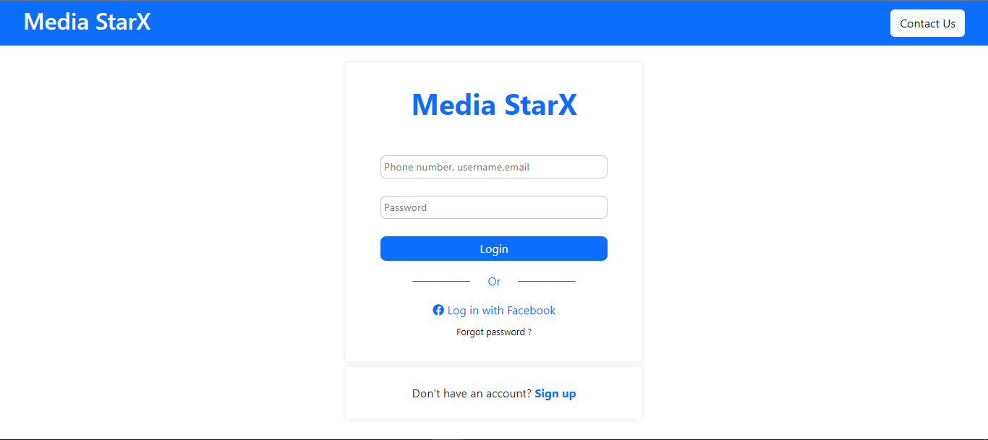

**NewsFeed Page:**

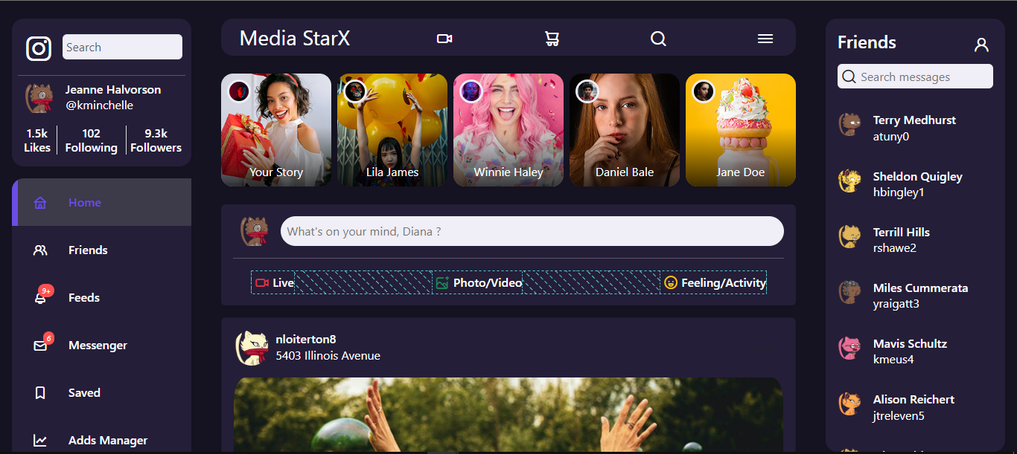

**Add Comment:**

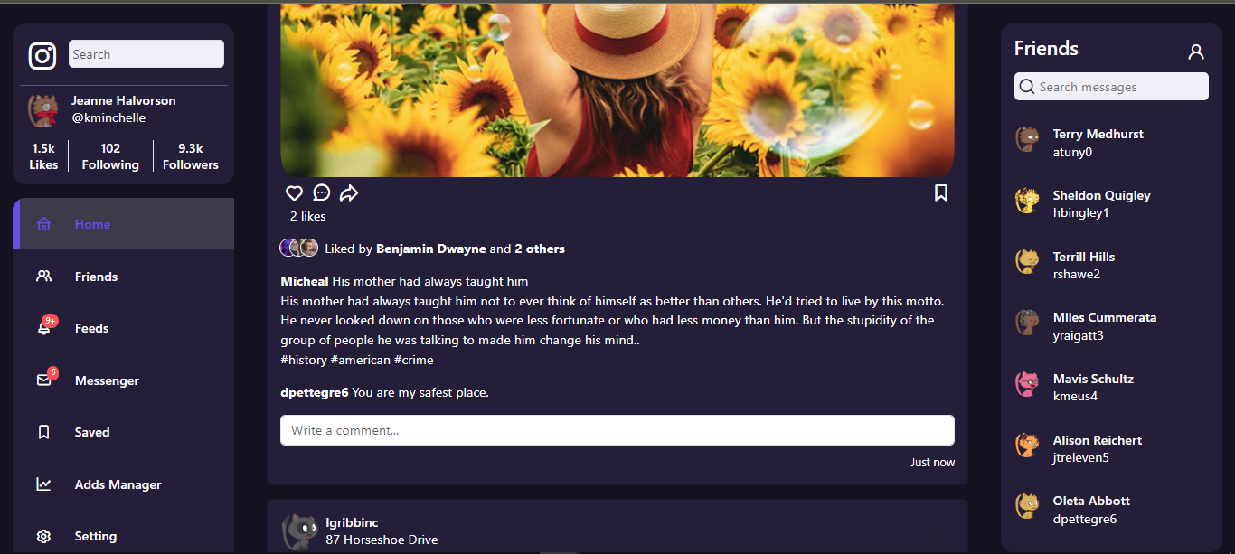

**Edit Comment:**

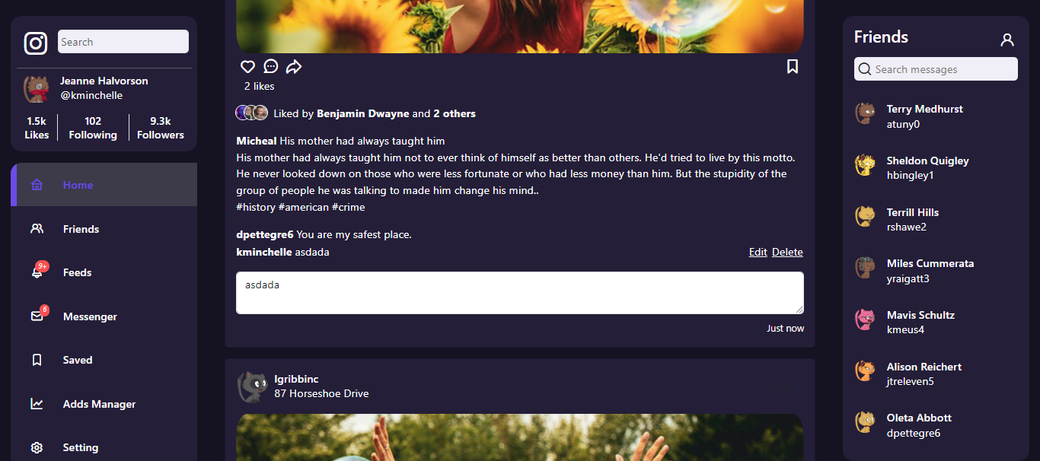

**Delete Comment:**

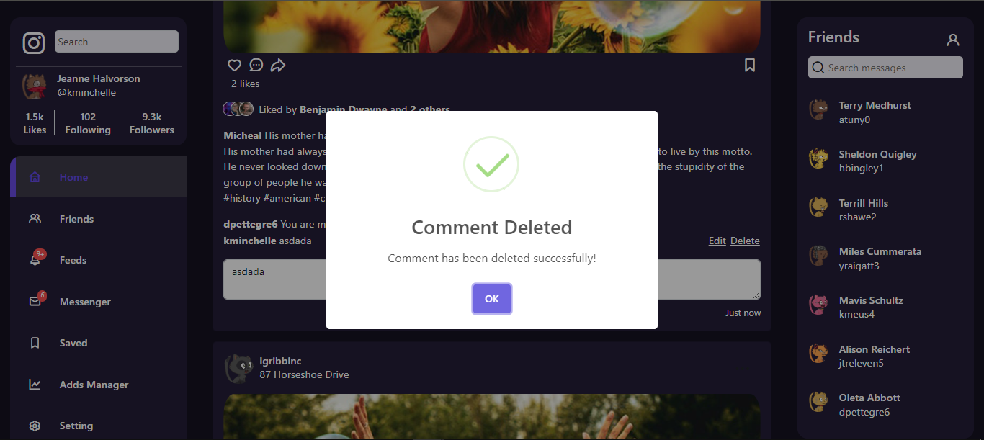

**Search Post:**

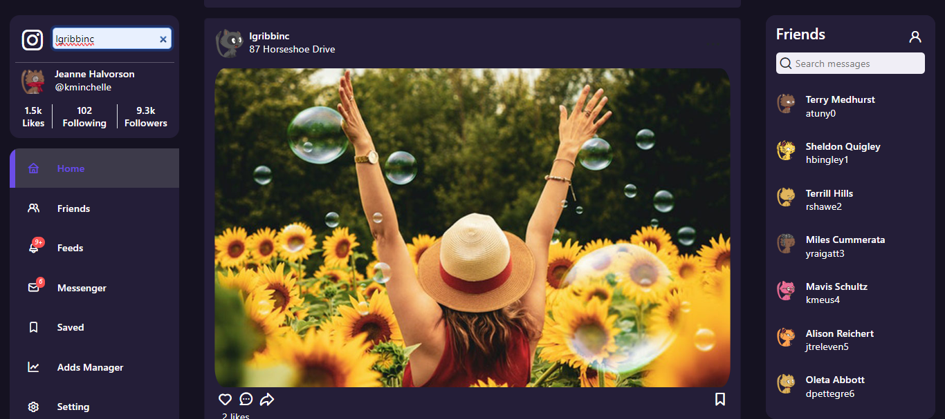

**Load Next Ten Posts:**

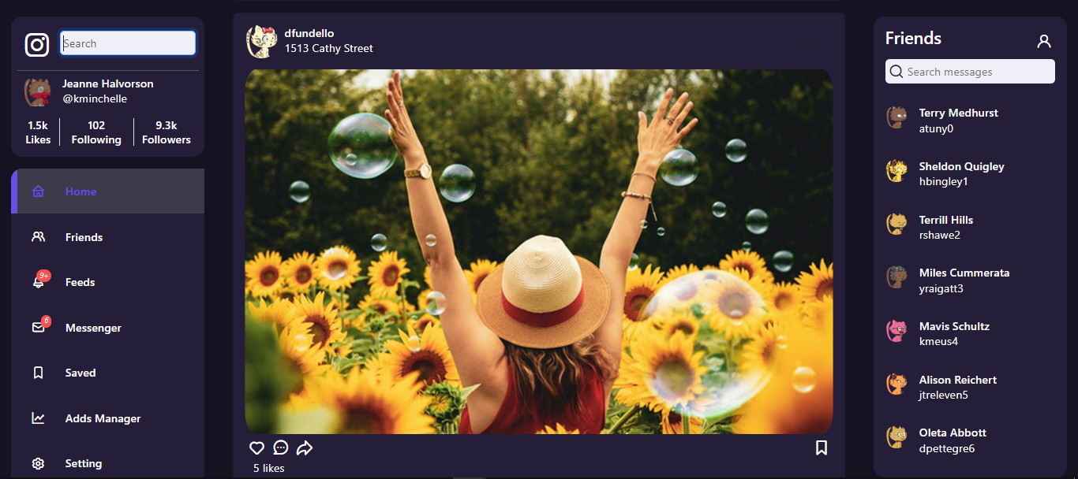

**User Profile:**

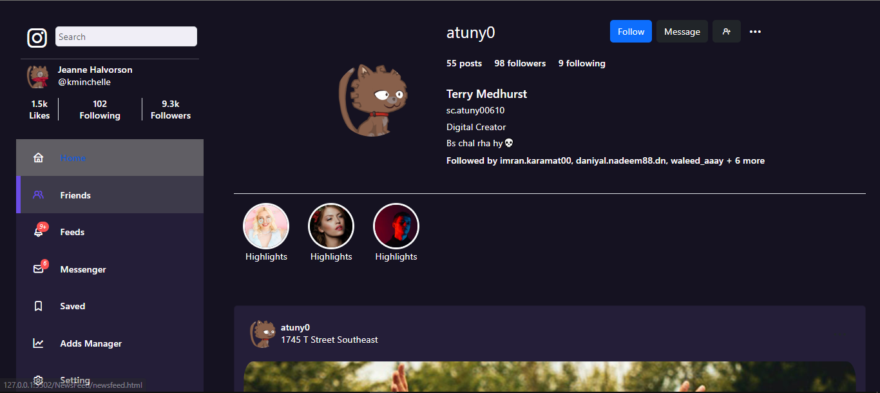

**Conclusion:**

Media StarX is a cutting-edge social networking platform designed to revolutionize online interactions. With its intuitive interface, robust features, and seamless performance, Media StarX offers users a dynamic and immersive experience. By empowering users to connect, share, and collaborate in meaningful ways, Media StarX is poised to shape the future of social networking. Welcome to Media StarX—where connections are limitless and possibilities abound.